NAME: login ID: precept:

COS 226 Midterm Exam, Spring 2009
This test is 10 questions, weighted as indicated. The exam is closed book, except that you are allowed to use a one page cheatsheet. No calculators or other electronic devices are permitted. Give your answers and show your work in the space provided. Put your name, login ID, and precept number on this page (now), and write out and sign the Honor Code pledge before turning in the test. You have 80 minutes to complete the test.
"I pledge my honor that I have not violated the Honor Code during this examination."
1 /5 2 /5 3 /5 4 /10 5 /10 6 /10 7 /10 8 /10 9 /20 10 /15 TOTAL /100
1. Partitioning (5 points). Give the result of partitioning the array with standard Quicksort partitioning (taking the N at the left as the partitioning element).
N E W P A R T I T I O N Q U E S T I O N
N E N I A E N I I T O T Q U R S T P O W
I E N I A E N I N T O T Q U R S T P O W
2. Estimating running time (5 points). Suppose that you run the program below (brute-force solution to the 4-sum problem) for N = 1000 and observe that it takes 1000 seconds. Predict its running time (in seconds) for N = 10000 and give a formula that estimates the running time as a function of N.
int brute(int a[], int N)
{ int i, j, k, m; for (i = 0; i < N; i++)
for (j = i+1; j < N; j++) for (k = j+1; k < N; k++) for (m = k+1; m < N; m++) if (a[i] + a[j] + a[k] + a[m] == 0) return 1; return 0; }
Predicted running time (in seconds) for N= 10000: ___10,000,000________
Estimated running time (in seconds) as a function of N: __.000000001 N^4__
3. Union-find trees (5 points). Circle the letters corresponding to arrays that could not possibly occur during the execution of weighted quick union with path compression:
i : 0 1 2 3 4 5 6 7 8 9
A. a[i]: 0 1 2 3 4 5 6 7 8 9
B. a[i]: 7 3 8 3 4 5 6 8 8 1
C. a[i]: 6 3 8 0 4 5 6 9 8 1
D. a[i]: 0 0 0 0 0 0 0 0 0 0
E. a[i]: 9 6 2 6 1 4 5 8 8 9
F. a[i]: 9 8 7 6 5 4 3 2 1 0
4. Sorting algorithms (10 points). Match each of the sorting algorithms below with its primary distinguishing characteristic (as presented in lecture and in the book) by writing the letter corresponding to each algorithm in the blank to the left of the corresponding characteristic. You should use each letter once and only once.
A. Mergesort __F__ Adapts well to duplicates
B. Quicksort __G__ Optimal time and space
C. Shellsort __D__ Adapts well to order
D. Insertion sort __C__ Not analyzed
E. Selection sort __A__ Stable and fast
F. 3-way quicksort __E__ Optimal data movement
G. Heapsort __B__ Fastest general-purpose sort
5. Dynamic arrays (10 points). The following list gives possible choices for using a dynamic array in a pushdown stack implementation. Write linear or quadratic in the blank following each choice to best describe the total time required in the worst case for a sequence of push()and pop()operations.
A. push(): always grow array by 1 pop(): always shrink array by 1 ___quadratic___
B. push(): double array if it is full pop(): never shrink array _____linear_____
C. push(): double array if it is full pop(): halve array if it is half full ___quadratic___
D. push(): double array if it is full pop(): halve array if it is 1/3 full _____linear_____
E. push(): double array if it is full pop(): shrink array by 99 if it has 100 empty slots ___quadratic___
- LLRB insertion (10 points). The following diagram shows a left-leaning red-black tree just after the node containing A is attached at the bottom. Thick lines are red links. Show the tree that results when this insertion is completed.
- ST implementations (10 points). The following is a list of possible reasons for choosing one of the Java ST implementations given in lecture over another. In the blanks provided, first list the ones that might reasonably justify using red-black trees rather than hash tables, then list the ones that might reasonably justify using hash tables over red-black trees. You need not use all the choices (do not list a choice if there are reasonable arguments on both sides).

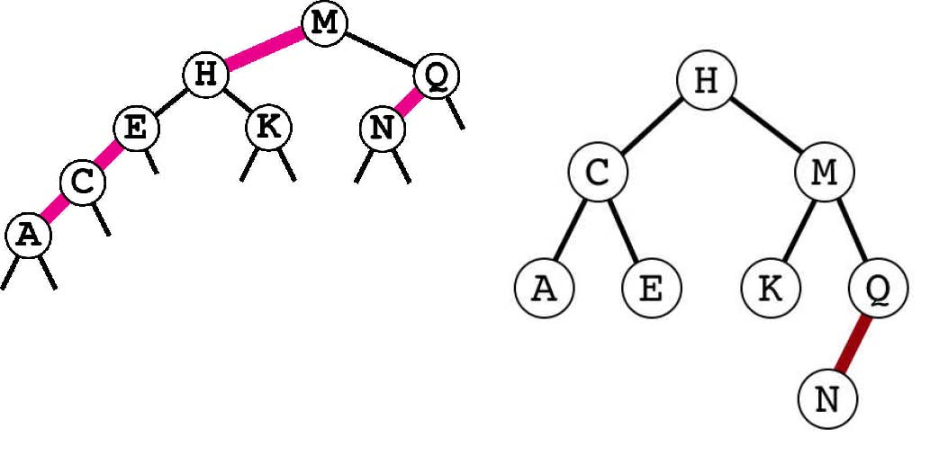
A. Easier to use properly for built-in key types (such as Stringand Integer)
B. Easier to use properly for user-defined key types
C. Extends to handle useful operations for ordered keys
D. Uses less space
E. Better worst-case performance guarantee
F. Faster for intkeys
Reasons to use red-black trees: ______B C E_______
Reasons to use hash tables: ______D F_____________
8. Red-black tree invariants (10 points). The following is a list of various descriptions of possible states of nodes in a red-black 2-3 tree. Circle the ones that cannot be found in a tree built by a sequence of put() operations. Recall that the color of a node is the color of the link to its parent, and that the root is always black.
A. Red node with red parent and two black children.
B. Black node with two null children.
C. Red node with two null children.
D. Black node with a left child described by C. and right child described by B.
E. Red node with black parent and black children.
F. Black node with red parent and one red child and one null child.
G. More red nodes than black nodes.
9. 7 sorting algorithms (20 points). The leftmost column is the original input of strings to be sorted, and the rightmost column is the sorted result. The other columns are the contents at some intermediate step during one of the 7 sorting algorithms listed below. Match up each algorithm by writing its letter under the corresponding column. Use each letter exactly once.
that been also also into been year been also even even down back even even with even back than ever come been than from will than been been fell been come been more more that come from from back down from next were from down next loss even even next over plea next even show more ever ever show plea well show ever with next into fell jobs show lost with fell more over fell from more than even more from were plea from have much that some over have over show jobs into over were very plea into plea than next jobs plea with next were jobs fell that have with fell fell lead ever lead time time lead time back time time fell loss loss were loss loss loss loss that loss lost ever with over show ever ever jobs time more lost also lost lost lost lost been also much also come more that also also also down next down down much more down down down lost over said have show said said said said said plea some lost plea some some some from come said have said that were have have have have show very some said very lead very over some some come very some than come come come very than into back will over that into into back that lead into very lead very lead fell into time back jobs time next time back back lead very year lead than year year year than year well will much with will will will show jobs were well well well well well well loss much will much will were much were much much well with
jobs year year plea with jobs ever will year
_F_ _B_ _E_ _D_ _C_ _G_ _A_
A. Bottom-up mergesort
B. Shellsort
C. Insertion sort
D. Quicksort (with no random shuffle)
E. Selection sort
F. Top-down mergesort
G. Heapsort
10. Dynamic median-finding (15 points). You need to support a client that reads a huge a stream of numbers that are all different and needs to keep track of the median element in the entire stream seen so far. For example, if the client gives you the numbers 2 9 7 4 1 and then asks for the median, you must return 4, and if the client then adds the numbers 6 8 5 and again asks for the median, you must return 5or 6. There are three requirements: First, you have only constant extra space (beyond what is needed to store the numbers themselves). Second, you must return the median in constant time. Third, you must process the Nth element in time proportional to log N.
Is it possible to discard some portion of the input, such that your algorithm finds the median element accurately even in the future?
A. Yes
B. No
Assume that you have seen N numbers and know that the median is of those numbers is v. Which of the following is true of the median when you process the (N+1)st number?
A. It does not change.
B. It is the largest of the numbers smaller than v.
C. It is the smallest of the numbers larger than v.
D. Either A. or B. or C.
E. Either B. or C, but not A.
F. It could be any of the numbers seen so far.
Which of the following data structures can support inserting numbers in logarithmic time and returning the maximum in constant time, using only a constant amount of extra space (beyond what is needed to store the numbers)?
A. BST.
B. Red-black BST.
C. Binary heap.
D. Sorted array.
E. Linked list.
In one or two sentences, describe how you would solve the problem.
Keep the median in v; use a max-oriented heap for keys less than v; use a min-oriented heap for keys greater than v. To insert, add the new key into the appropriate heap, replace v with the value extracted from that heap.

